SIMATS ENGINEERING (SAVEETHA SCHOOL OF ENGINEERING)
Department of Computer Science and Engineering

ASSESSMENT TOOL 2 – CASE STUDY

Course Code: | CSA0612 | Course Title: | Design and Analysis of Algorithms
CO Assessed: | CO3: Articulation (BL4, BL5) | Assessment: | Assessment Tool 2 – Case Study
Weightage: | 20% of CIA | Total Marks: | 100
CO3 Statement: | Design Divide and Conquer algorithms for Merge Sort, Quick Sort, Binary Search and Matrix Multiplication
Student Name: | DIVYASREE.P (192565016) | Reg. No.: | 192565016
Section / Batch: | 2025 | Date: | 26/08/2026
Instructions to Students
- Answer the following question. Total Marks: 100.
- Carefully analyze the given case study questions.
- Explain in detail with sample code if needed.
- Clearly identify all key issues, provide an in-depth analysis, and propose innovative, feasible solutions with strong justification.

Question Type | Focus Area | Questions
Case Study | Focus on Design Divide and Conquer algorithms: Merge Sort, Quick Sort, Binary Search and Matrix Multiplication | Q1
SECTION A – CASE STUDY

Code of Conduct
I DIVYASREE.P (192565016) (Name / Reg No) certify that this submission is my original work and that I have adhered to the guidelines specified for this assessment. I understand that any violation of academic integrity rules will result in disciplinary action.
Signature of the Student:

RUBRICS FOR CALCULATION

Case Study
Criteria | Weightage | Level 4 – Exemplary | Level 3 – Proficient | Level 2 – Developing | Level 1 – Beginning
Understanding of Case | 25% | Thorough understanding; clearly identifies all key issues | Good understanding with most issues identified | Basic understanding; some issues missed | Poor understanding; problem not identified correctly
Application of Concepts | 25% | Effectively applies relevant concepts to analyze the case deeply | Applies appropriate concepts with minor gaps | Limited application of concepts | Fails to apply relevant concepts
Analysis | 20% | In-depth analysis with strong  reasoning and insights | Good analysis with logical reasoning | Basic analysis with limited depth | Weak or no analysis; lacks reasoning
Solution Design | 20% | Innovative, feasible solutions with strong justification | Logical solutions with adequate justification | Basic solutions with weak justification | Incorrect or no solution provided
Clarity | 10% | Clear, well-structured, and easy to  understand | Organized and understandable presentation | Limited clarity and structure | Poor clarity; difficult to understand

Marks Evaluation:
Criteria | Wt. | Level 4 – Exemplary | Level 3 – Proficient | Level 2 – Developing | Level 1 – Beginning
Understanding of Case | 25%
Application of Concepts | 25%
Analysis | 20%
Solution Design | 20%
Clarity | 10%
Total Marks (100):

Faculty In-charge | Course Coordinator | Head of Department
Name: | Name: | Name:
Signature: | Signature: | Signature:
Date: | Date: | Date:

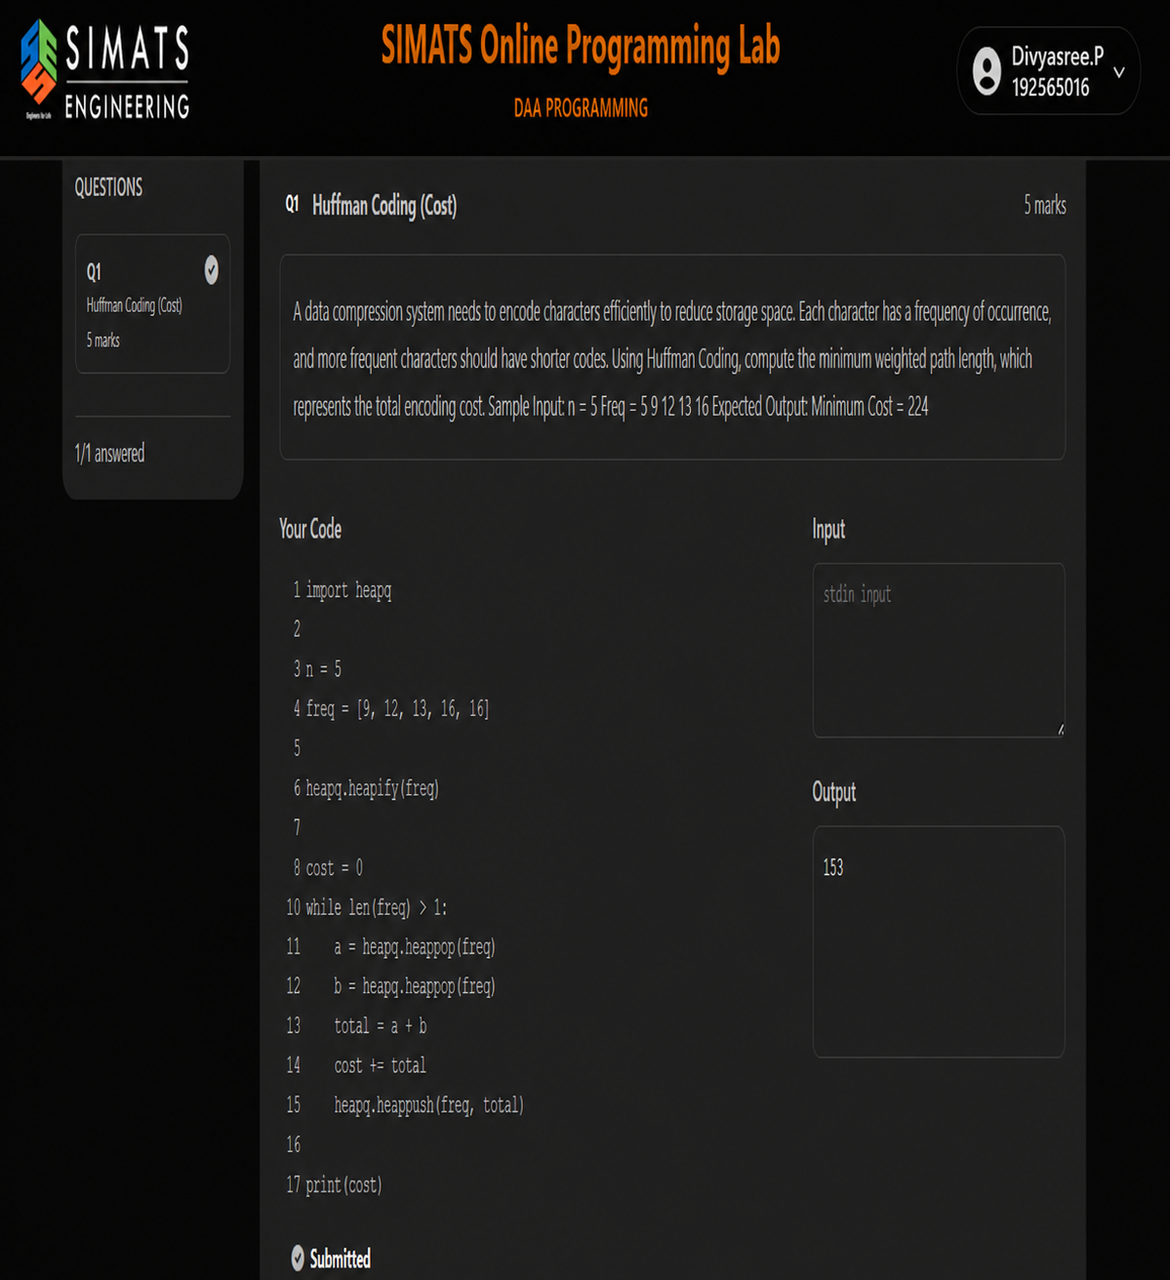

REPORT

1.AIM

The aim of this program is to solve the N-Queens problem using the backtracking technique. The objective is to place N queens on an N × N chessboard so that no two queens attack each other and to count the total number of valid arrangements.

2. Problem Description

The N-Queens problem is a classical problem in computer science that involves placing N queens on an N × N chessboard. Since a queen can attack another queen in the same row, column, or diagonal, every placement must satisfy these restrictions. The program explores possible placements systematically and counts only those arrangements that satisfy all the conditions.
The problem demonstrates the use of recursion, constraint checking, and backtracking. Instead of checking every complete board configuration, the algorithm rejects an arrangement as soon as it becomes invalid. This reduces unnecessary exploration.

3. Objective

The main objective is to design an algorithm that can explore all possible queen placements row by row, verify whether each position is safe, and count every complete valid arrangement. The method must not miss any valid configuration or count an invalid configuration.

4. Algorithm – Backtracking

Backtracking is a problem-solving technique that builds a solution step by step. In the N-Queens problem, one queen is considered for each row. For the current row, every column is examined. If a position is safe, the queen is temporarily placed there and the algorithm proceeds to the next row.
If the next row cannot be completed, the algorithm returns to the previous row, removes the previously placed queen, and tries another column. This process continues until all possible configurations have been considered.
A position is considered safe when there is no previously placed queen in the same column and no previously placed queen on either diagonal. When queens have been successfully placed in all N rows, the solution counter is increased by one.

5. Working Principle

The program first accepts the board size N from the user. A board representation is maintained to record the column occupied by a queen in each row. A counter is initialized to zero to store the number of valid solutions.
The recursive process begins from the first row. For each row, the program checks every possible column. Unsafe positions are immediately rejected. For every safe position, the queen is placed and the next row is processed recursively. After returning from the recursive call, the placement is removed so that another possibility can be tested.

